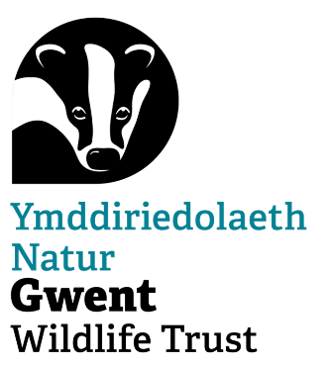**Volunteer Warden Role Description**

**Locations:**

1. Croes Robert Wood (near Trellech) - A stunning ancient woodland with carpets of bluebells in spring, the elusive hazel dormouse and plenty of other species, this reserve is a special place to spend your time.
2. River Meadow (near Llanvair Kilgeddin) – Our newest reserve nestled alongside the Usk. Hay meadows, streams and a woodland make this site a hidden gem and refuge for wildlife such as Stonechat and damselflies.
3. Springdale Farm (near Usk) – One of our larger reserves with a mix of hay meadows, grazing pastures and mixed woodland. You can often see wildlife such as Kestrels and Foxes here.

**Purpose of the Role**

The volunteer warden role involves reporting on the current status of the reserve, assisting with reserve tasks and surveys, engaging with visitors, recording information and maintaining safety. Previous experience working or volunteering with wildlife or nature reserves is not necessary but a willingness to volunteer independently is required. You will be asked to sign a volunteer warden agreement and adhere to GWT policies especially health and safety.

**The volunteer warden role would involve the following**

Essential:

* general walkovers of the reserve, noting fallen trees, anything dangerous or interesting, wildlife sightings etc
* assist Nature Recovery Officers with practical reserves tasks, flexible to abilities and availability
* checking infrastructure including water supply for damage
* general upkeep e.g. clearing signs, gates and footpaths
* reporting to the Nature Recovery Officer a reserve update at least monthly preferably fortnightly

Optional:

* unsupervised hand tool tasks
* assisting Senior Conservation Grazing Officer with GWT livestock checks
* writing short articles for GWT magazine/e-newsletter
* evidence surveys of flora and fauna

**Benefits**

* training opportunities including first aid
* equipment, PPE and clothing including GWT branded top
* increased knowledge of local wildlife and habitats
* opportunity to have a positive impact
* eligible to claim expenses up to a 20 mile round trip at 25p per mile

Rose Scott, Assistant Nature Recovery Officer, will be responsible for leading and supporting you as a volunteer warden ([rscott@gwentwildlife.org](mailto:rscott@gwentwildlife.org))

This agreement is not binding in any way, nor is it a contract of employment.