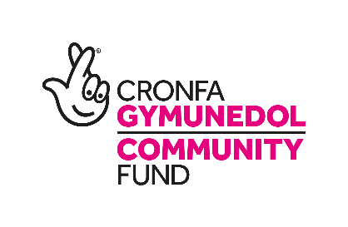
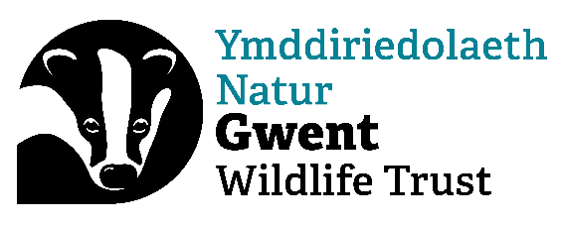

Gwent Wildlife Trust

Wild Health Officer (Maternity Cover)

Title: Wild Health Officer (Maternity Cover)
Contract: Fixed term, full time (37.5 hrs), for 6 months (with possibility of extension). Some evening and weekend work will be expected. Part time will be considered.
Reports to: Senior Wild Health Officer
Responsible for: Volunteers & project participants
Location: Working across Gwent. Office time at GWT Headquarters, Mamhilad Park Estate, NP4 0HZ, or other GWT offices, with homeworking as required.
Salary: £26,672

Overall purpose
- Deliver the Wild Health Project across Gwent alongside our Senior Wild Health Officer
- Support people of all abilities, often from under-represented groups, to access the outdoors and experience the physical and mental benefits of connecting with nature.

Main responsibilities
- Planning and delivering a programme of person-centred outdoor recreational or practical conservation activities across Gwent, for individuals who may benefit from being connected to nature.
- Working closely with participants, other GWT staff and partner organisations to ensure the sessions are at the appropriate level for the participants, as well as contributing to nature’s recovery (through practical activities or increasing awareness and understanding).
- Developing and maintaining strong relationships with partners, including health care providers, Aneurin Bevan University Health Board and third sector organisations, to ensure coordinated and appropriate delivery, as well as to signpost and refer potential participants to the Wild Health project.
- Promoting the project to a diverse range of participants from all backgrounds and therefore ensuring that sessions are accessible to all.
- Playing a key role in the monitoring and evaluation of the project, working alongside peers and line manager, to capture and monitor the benefits to individuals participating in the project.
- Ensuring the terms of funding agreements are met, that detailed up to date records are kept of activities and participants, and that National Lottery reports and claims are submitted on time.
- Contributing towards the development and management of project budgets.
- Working with the Senior Wild Health Officer, Head of Nature Based Solutions and the Fundraising Manager to develop and submit proposals to continue and expand our Health & Wellbeing work
- Sharing project updates and results (written and verbal presentations) to stakeholders and partners
- Communicating and promoting our health and wellbeing work, as well as the wider work of GWT, through a variety of media, working with GWT’s Marketing Team to do so
- Reading and abiding by all GWT’s Policies, Processes and Practices with particular reference to the Staff and Organisational Handbooks, HR Policies and Health and Safety Management System
- Attending meetings of the Trust including but not limited to All Staff and One to One’s
- Promoting membership of GWT and representing your work and GWT’s projects and campaigns in the media as required, ensuring that NLCF requirements are met as part of this project promotion.
- Carrying out any other varied duties that may be required, appropriate to the nature of the post

The Post
The Wild Health Officer (maternity cover) sits within the Nature Based Solutions Team, which drives our priority of helping nature to help us. This role will work alongside a Senior Wild Health Officer, Youth Engagement Officers, a River Restoration Officer and Community Organiser, and joins us at a pivotal time where we are expanding our work into Nature Based Solutions, demonstrating how the restoration of ecosystem services can deliver for people and wildlife.

This role will enable us to continue our delivery of exemplary, targeted and impactful interventions to communities across Gwent, supporting them to access the outdoors safely and connecting them to nature. Through continuous monitoring, reflection and evaluation, the role will ensure that the Wild Health Project is meeting its objectives of connecting people to nature, improving their wellbeing, increasing their motivation to access the outdoors, increasing community connection and increasing ecosystem resilience through practical work on the ground.

The position is subject to an Enhanced Disclosure and Barring Service check.

Candidates should be able to demonstrate commitment to equal opportunities and be able to work out-of-office hours when required. The post holder will be required to attend other meetings elsewhere in Gwent and occasionally elsewhere in the UK.

We want our staff to be as diverse as nature, so we particularly encourage applications from people who are underrepresented within our sector, including people from minority ethnic backgrounds and people with disabilities. We are committed to creating a movement that recognises and truly values individual differences and identities.

We are committed to offering an interview to anyone with a disability that meets all the essential criteria for the post. Please let us know if you require any adjustments to make our recruitment process more accessible.

This post has received funding through the National Lottery Community Fund, People and Place fund.
PERSON SPECIFICATION
The qualities needed for this post are listed below.
(E – Essential; D – Desirable)

Experience
- Planning and delivering high quality, well organised, inclusive activities in the outdoors (E)
- Working with and safeguarding adults at risk and/or adults experiencing low level mental health conditions (E)
- Working in partnership with other organisations and community stakeholders (E)
- Managing volunteers and leading volunteer groups outdoors (E)
- Work plan production, record-keeping and reporting internally and to funders (E)
- Development and implementation of Health and Safety Codes of Practice and Risk Assessments (E)
- Management of project budgets (D)
- Delivering practical conservation work tasks with volunteers (D)

Skills
- Good communication skills with all abilities - written and oral (E)
- Excellent interpersonal skills - critical-listening, mediation, persuasion, empathy, non-judgemental (E)
- Excellent attention to detail (E)
- Full UK driving license (E)
- Ability to work in a busy environment to deadlines, managing multiple priorities (E)
- Ability to work independently, using own initiative, as well working as part of a team (E)
- IT literate (E) - Microsoft Office including Excel (E)

Knowledge and Qualifications
- Safeguarding adults at risk (E)
- Knowledge of and an interest in natural history (E)
- Understanding of the barriers to community involvement and how they may be overcome (E)
- Welsh language (D)

Personal Qualities
- Inquisitive and solutions focussed, always seeking to improve their and their teams work (E)
- Responsible attitude with good organisational and time management skills (E)
- Self-reliant with initiative and a mature, professional, flexible approach (E)
- Eager to learn and implement new skills for the role (E)
- Passion and enthusiasm for work with communities, for inclusion and for nature (E)
- Able to convey enthusiasm and inspire people to become involved (E)
- Approachable and with the ability to build strong relationships with diverse audiences (E)

Candidates should be able to demonstrate commitment to equal opportunities, be able to work out-of-office hours occasionally, and to hold a full driving licence. The post holder will be required to work across Gwent and occasionally attend meetings elsewhere in the UK.

To discuss this post informally, contact Ian Thomas ithomas@gwentwildlife.org | 07810 853794

